# CASE STUDY

###### A report submitted in partial fulfilment of the requirements for the Award of Degree of

**BACHELOR OF TECHNOLOGY**

**in**

**COMPUTER SCIENCE AND ENGINEERING**

**by**

**TALEEB DILAWAR CHOGULE**

**Regd. No.: 322132910044**

**Under Supervision of**

**OBJECT ORIENTED SOFTWARE ENGINEERING**

**SRAVYA**



**DEPARTMENT OF COMPUTER SCIENCE AND ENGINEERING**

**SANKETIKA VIDYA PARISHAD ENGINEERING COLLEGE (Approved by AICTE, Affiliated to ANDHRA UNIVERSITY, Visakhapatnam)**

**PM Palam, Visakhapatnam - 530041**

**DEPARTMENT OF COMPUTER SCIENCE AND ENGINEERING SANKETIKA VIDYA PARISHAD ENGINEERING COLLEGE**



CERTIFICATE

This is to certify that the “**Case Study”** submitted by **TALEEB DILAWAR CHOGULE** (Regd. No.: 322132910044) is work done by his and submitted during 2024 - 2025 academic year, in partial fulfilment of the requirements for the award of the degree of **BACHELOR OF TECHNOLOGY in COMPUTER SCIENCE AND ENGINEERING.**

**Case Study Guide Head of the Department of CSE**

(Assistant professor, CSE) **Dr.K.N.S. Lakshmi**

**Sravya**

**TABLE OF CONTENTS**

|  |  |  |
| --- | --- | --- |
| **S.no** | **Title** | **Page.no** |
|  | **MODULE-I** |  |
|  | **Unified Modeling Language** |  |
| **1.** | Introduction to UML | **1-3** |
| **2.** | Building blocks of UML | **4-6** |
| **3.** | Advantages of UML | **7-8** |
| **4.** | Relationships in UML | **9-13** |
| **5.** | UML Diagram | **14-20** |
|  | **MODULE-II** |  |
|  | **Net Support Web-Site** |  |
| **1.** | Introduction to Customer Support System | **22-30** |
| **2.** | UML Diagrams of Customer Support System | **31-44** |

|  |  |  |
| --- | --- | --- |
|  | **MODULE-III** |  |
|  | **Net Support Web-Site** |  |
| **1.** | Abstract | **45** |
| **2.** | Introduction | **4648** |
| **3.** | Problem statement | **49-51** |
| **4.** | Modules | **52-55** |
| **5.** | UML Diagrams | **56-68** |

# MODULE - I

**INTRODUCTION**

### Introduction to UML:

### Unified Modeling Language (UML) is a standardized modeling language used in software engineering to visualize, specify, construct, and document the components of a software system. UML provides a set of graphical notations that help developers and stakeholders communicate complex system designs in an understandable and structured manner. Since its inception in the 1990s, UML has become an essential tool for software architects, designers, and developers worldwide.

### Using UML, developers can communicate more effectively with stakeholders and other developers, reduce misunderstandings, and ensure that everyone is on the same page regarding the design and implementation of the software system. UML is a widely used modelling language in software development because it offers several benefits for developers, stakeholders, and the overall software development process. One of the primary benefits of UML is that it provides a standardized notation and language for modelling software systems. This allows developers and stakeholders to communicate more effectively and accurately, and reduces the risk of misunderstandings or errors. Additionally, UML provides a range of diagrams and notations that can be used to model various aspects of a software system, including its structure, behavior, and interactions.

### History and Evolution of UML

### UML was developed by Grady Booch, James Rumbaugh, and Ivar Jacobson at Rational Software in the mid-1990s. Before UML, software modeling methodologies varied widely, leading to inconsistencies and inefficiencies. The three creators combined their individual methodologies—Booch Method, Object-Modeling Technique (OMT), and Object-Oriented Software Engineering (OOSE)—to create a unified approach to software modeling. In 1997, UML was adopted by the Object Management Group (OMG) as a standard modeling language and has since undergone various updates to accommodate the evolving needs of software engineering.

### Fundamental Parts of UML

### UML consists of multiple diagrams categorized into three main groups: structure diagrams, behavior diagrams, and interaction diagrams.

### Structure Diagrams: These diagrams define the static aspects of a system, including its components, objects, and relationships. The most commonly used structure diagrams include:

### Class Diagram: Represents the classes, attributes, methods, and relationships between different objects in a system.

### Object Diagram: Shows the instances of classes and their relationships at a particular moment.

### Component Diagram: Depicts the physical components of a system and their interdependencies.

### Deployment Diagram: Illustrates the hardware components and how software components are distributed across them.

### Behavior Diagrams: These diagrams focus on the dynamic aspects of a system and define how it behaves over time. Important behavior diagrams include:

### Use Case Diagram: Represents the interactions between users (actors) and the system through different use cases.

### State Diagram: Describes the different states an object can be in and the transitions between these states.

### Activity Diagram: Shows the flow of activities in a system, similar to a flowchart.

### Interaction Diagrams: These diagrams detail how different components of a system interact with one another. Examples include:

### Sequence Diagram: Represents the sequence of interactions between objects over time.

### Collaboration Diagram: Focuses on the relationships between objects and their interactions.

### Timing Diagram: Shows changes in state or conditions of an object over time.

### Importance and Applications of UML

### UML is widely used in software development for various purposes, including:

### System Design and Documentation: UML helps in designing system architecture before actual coding begins, ensuring clarity and consistency.

### Requirement Analysis: Use case diagrams assist in capturing user requirements and system functionalities.

### Code Generation: Some development tools can automatically generate code from UML diagrams, reducing development time.

### Communication and Collaboration: UML provides a common language for developers, designers, and stakeholders to collaborate effectively.

### System Maintenance and Upgradation: UML diagrams serve as valuable documentation for future modifications and system enhancements.

**THE BUILDING BLOCKS OF UML**

Unified Modeling Language (UML) is a standardized modeling language used in software engineering to visualize, specify, construct, and document the artifacts of a software system. UML provides a common vocabulary and framework for software developers, enabling them to communicate ideas and designs effectively. At its core, UML is composed of several building blocks that form the foundation of its modeling capabilities. These building blocks include things, relationships, and diagrams. Understanding these elements is essential for mastering UML and leveraging its full potential in software development.

1. **Things: The Basic Elements of UML**

Things are the fundamental components of UML, representing the abstractions that are modeled. They are categorized into four main types: structural things, behavioral things, grouping things, and annotational things.

* **Structural Things:** These represent the static parts of a system and include:
* Classes: Templates for objects, defining attributes and operations.
* Objects: Instances of classes, representing specific entities.
* Interfaces: Contracts that define a set of operations.
* Components: Modular parts of a system with well-defined interfaces.
* Nodes: Physical elements like hardware devices or execution environments.
* **Behavioral Things:** These represent the dynamic aspects of a system and include:
* Interactions: Messages exchanged between objects to achieve a task.
* State Machines: Models that describe the states and transitions of an object.
* Use Cases: Descriptions of system functionality from a user's perspective.
* **Grouping Things**: These are used to organize and structure the model:
* Packages: Containers for grouping related elements.
* **Annotational Things**: These provide additional information or explanations:
* Notes: Comments or explanations attached to elements in the model.

1. **Relationships: Connecting the Elements**

Relationships define how things are connected or related to one another in a UML model. They are essential for expressing the structure and behavior of a system. The primary types of relationships in UML are:

* Dependencies: A relationship where one element depends on another.
* Associations: A structural relationship between two or more elements.
* Generalizations: A relationship where one element is a specialized form of another (e.g., inheritance).
* Realizations: A relationship where one element implements the behavior specified by another (e.g., a class implementing an interface).

These relationships help to define the interactions and hierarchies within a system, making the model more meaningful and easier to understand.

1. **Diagrams: Visualizing the Model**

Diagrams are the visual representations of UML models, providing different perspectives of a system. UML defines 14 types of diagrams, broadly categorized into structural diagrams and behavioral diagrams.

* **Structural Diagrams:** These focus on the static structure of a system:
* Class Diagrams: Show classes, attributes, operations, and relationships.
* Object Diagrams: Depict instances of classes and their relationships.
* Component Diagrams: Illustrate the organization and dependencies of components.
* Deployment Diagrams: Show the physical deployment of artifacts on nodes.
* **Behavioral Diagrams**: These focus on the dynamic behavior of a system:
* Use Case Diagrams: Describe system functionality from a user's perspective.
* Sequence Diagrams: Show interactions between objects in a time-ordered sequence.
* Activity Diagrams: Model workflows and processes.
* State Machine Diagrams: Represent the states and transitions of an object.

Each diagram type serves a specific purpose, allowing developers to model different aspects of a system effectively.

1. **The Role of UML in Software Development**

UML's building blocks enable developers to create comprehensive models that capture both the structure and behavior of a system. By using UML, teams can:

* Improve communication and collaboration.
* Identify potential issues early in the design phase.
* Document system requirements and designs clearly.
* Facilitate the transition from design to implementation.

**ADVANTAGES OF UML**

Unified Modeling Language (UML) is a powerful tool widely used in software engineering to model, visualize, and document software systems. Its standardized approach offers numerous advantages that make it an essential part of the software development lifecycle. Below are the key benefits of using UML:

1. **Improved Communication and Collaboration**

UML provides a common language and visual representation for software developers, designers, stakeholders, and other team members. This standardization ensures that everyone involved in the project can understand and discuss the system's design, requirements, and functionality without ambiguity. It bridges the gap between technical and non-technical stakeholders, fostering better collaboration.

1. **Clear Visualization of System Design**

UML diagrams offer a visual representation of complex systems, making it easier to understand the structure, behavior, and interactions within the system. By breaking down the system into manageable components, UML helps developers and stakeholders grasp the big picture as well as the finer details.

1. **Early Detection of Design Flaws**

By creating UML models during the design phase, developers can identify potential issues, inconsistencies, or gaps in the system before implementation begins. This proactive approach reduces the risk of costly errors and rework later in the development process.

1. **Comprehensive Documentation**

UML serves as a formal documentation tool, capturing the system's requirements, design, and architecture in a structured and standardized format. This documentation is invaluable for future maintenance, updates, or onboarding new team members, as it provides a clear and consistent reference.

1. **Supports Object-Oriented Design**

UML is particularly well-suited for object-oriented programming (OOP). It allows developers to model classes, objects, inheritance, and relationships, making it easier to design and implement systems using OOP principles.

1. **Facilitates Reusability**

UML encourages modular design by breaking down systems into components, classes, and packages. This modularity promotes reusability, as developers can reuse well-defined components in other projects or parts of the same system.

1. **Enhances Scalability**

UML models provide a clear blueprint of the system, making it easier to scale and extend the system as requirements evolve. Developers can analyze the impact of changes and plan for future enhancements without disrupting the existing structure.

1. **Supports Multiple Perspectives**

UML offers a variety of diagram types (e.g., class diagrams, sequence diagrams, use case diagrams) that cater to different aspects of the system. This flexibility allows teams to focus on specific areas, such as system structure, behavior, or user interactions, depending on their needs.

1. **Improves Efficiency**

By providing a clear and structured approach to system design, UML reduces the time spent on misunderstandings, rework, and debugging. It streamlines the development process, leading to faster and more efficient project delivery.

1. **Standardization Across Industries**

As a widely accepted standard, UML ensures consistency across projects and organizations. This standardization makes it easier for teams to adopt best practices, share knowledge, and integrate tools and processes.

1. **Facilitates Testing and Validation**

UML models can be used to create test cases and validate system behavior. For example, sequence diagrams and state machine diagrams help developers understand how the system should behave under different conditions, enabling more effective testing.

**RELATIONSHIP IN UML**

In Unified Modeling Language (UML), relationships are the connections between elements that define how they interact or relate to one another within a system. Relationships are essential for modeling the structure, behavior, and functionality of a software system. UML defines several types of relationships, each serving a specific purpose in the design and analysis of systems. Below is a detailed explanation of the key relationships in UML:

1. **Dependency**

* Definition: A dependency is a relationship where one element (the client) depends on another element (the supplier) for its specification or implementation. Changes to the supplier may affect the client.
* Notation: A dashed arrow pointing from the client to the supplier.
* Example: A class that uses a method from another class temporarily (e.g., a utility function) has a dependency on that class.

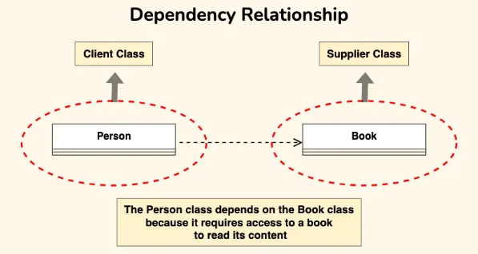

1. **Association**

* Definition: An association represents a structural relationship between two or more elements, indicating that they are connected or related in some way. It can be bidirectional or unidirectional.
* Notation: A solid line connecting the related elements. Arrows can be added to indicate directionality.
* **Types:**
* Binary Association: Between two classes.
* N-ary Association: Between three or more classes.
* Example: A Student class is associated with a Course class, indicating that students enroll in courses.

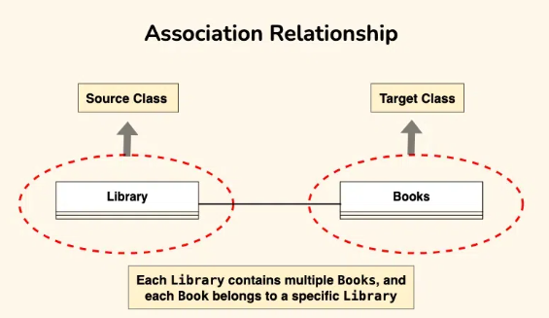

1. **Aggregation**

* Definition: Aggregation is a special type of association that represents a "whole-part" relationship. It implies that the part can exist independently of the whole.
* Notation: A solid line with a hollow diamond on the side of the whole.
* Example: A Department class aggregates Professor classes, meaning a department consists of professors, but professors can exist without being part of a department.

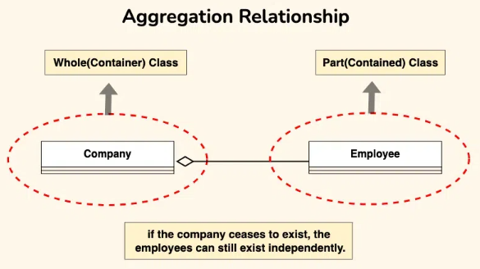

1. **Composition**

* Definition: Composition is a stronger form of aggregation where the part cannot exist independently of the whole. If the whole is destroyed, the parts are also destroyed.
* Notation: A solid line with a filled diamond on the side of the whole.
* Example: A Car class is composed of Engine and Wheel classes. If the car is destroyed, the engine and wheels are also destroyed.

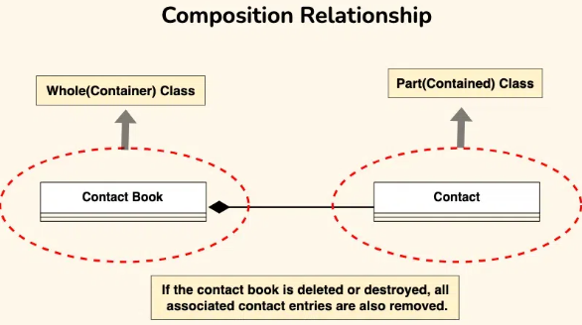

1. **Generalization**

* Definition: Generalization represents an inheritance relationship between a general element (parent) and a more specific element (child). The child inherits attributes and behaviors from the parent.
* The Bank Account class serves as the generalized representation of all types of bank accounts, while the subclasses (Current Account, Savings Account, Credit Account) represent specialized versions that inherit and extend the functionality of the base class.
* Notation: A solid line with a hollow arrowhead pointing from the child to the parent.
* Example: A Vehicle class is a generalization of Car and Truck classes, meaning cars and trucks inherit properties from the vehicle class.

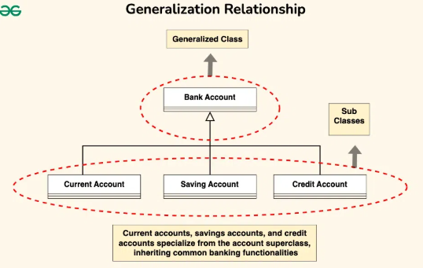

1. **Realization**

Definition: Realization is a relationship where one element (e.g., a class) implements the behavior specified by another element (e.g., an interface). It is often used to model the relationship between interfaces and their implementations.

* Notation: A dashed line with a hollow arrowhead pointing from the implementing class to the interface.
* Example: A Printer class realizes the Printable interface, meaning the printer implements the methods defined in the interface.

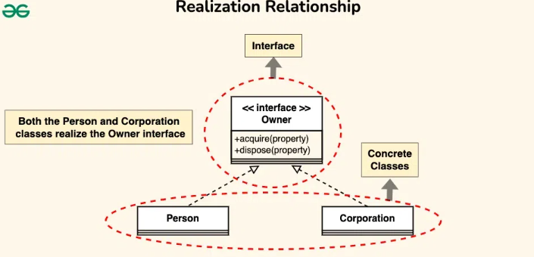

1. **Association Classes**

* Definition: An association class is used when an association itself has attributes or operations. It is represented as a class attached to the association line.
* Notation: A dashed line connecting the association class to the association line.
* Example: In a relationship between Student and Course, an association class Enrollment can be used to store attributes like grade or enrollmentDate.

1. **Reflexive Relationships**

* Definition: A reflexive relationship is an association where an element is related to itself. It is often used to model hierarchical or recursive structures.
* Notation: A solid line with arrows pointing back to the same class.
* Example: A Person class may have a reflexive relationship to model a "manager-employee" hierarchy.

**UML DIAGRAMS**

Unified Modeling Language (UML) is a standardized visual modeling language used to design and document software systems. UML provides a variety of diagrams that help developers, designers, and stakeholders visualize, understand, and communicate different aspects of a system. These diagrams are broadly categorized into two types: structuraldiagrams and behavioraldiagrams. Below is a detailed explanation of the most commonly used UML diagrams.

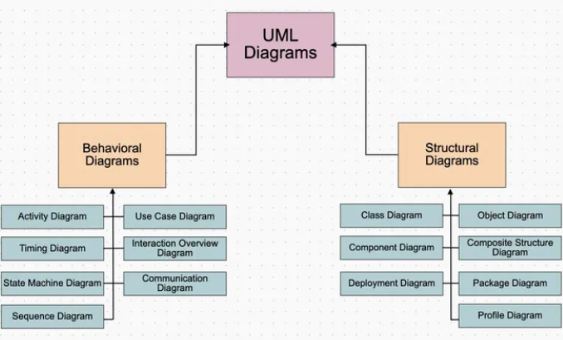

1. **Structural Diagrams**

Structural diagrams focus on the static structure of a system, representing the components, objects, and relationships that make up the system.

1. **Class Diagram**

* **Purpose**: Represents the static structure of a system by showing classes, their attributes, methods, and relationships.
* **Key Elements**: Classes, attributes, methods, associations, inheritance, and interfaces.
* **Example**: A Car class with attributes like model and color, and methods like start() and stop().
* **UML CLASS NOTATION**

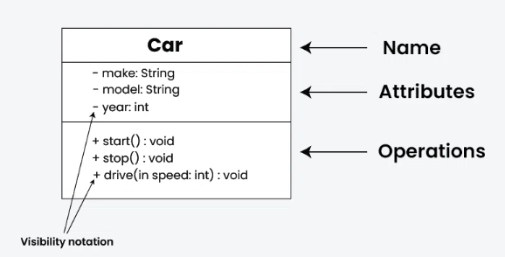

* **UML CLASS DIAGRAM**

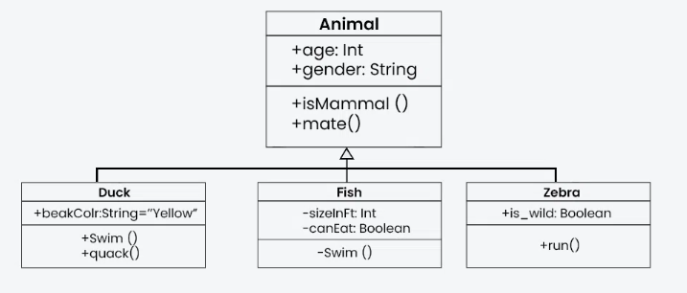

1. **Object Diagram**

* Purpose: Shows instances of classes (objects) and their relationships at a specific point in time.
* Key Elements: Objects, attributes, and links.
* Example: An object myCar of the Car class with specific values for model and color.

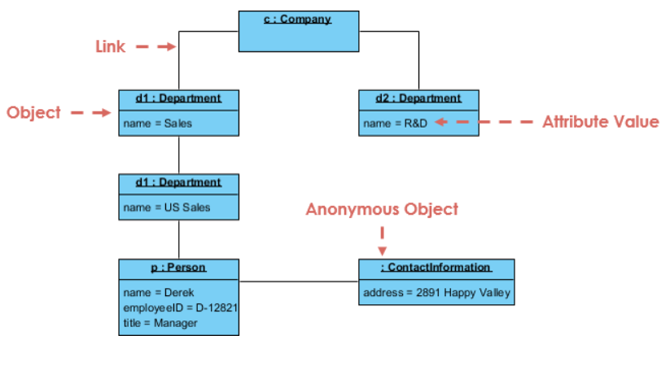

1. **Component Diagram**

* Purpose: Illustrates the organization and dependencies among physical or logical components in a system.
* Key Elements: Components, interfaces, and dependencies.
* Example: A Payment component that depends on a Database component.

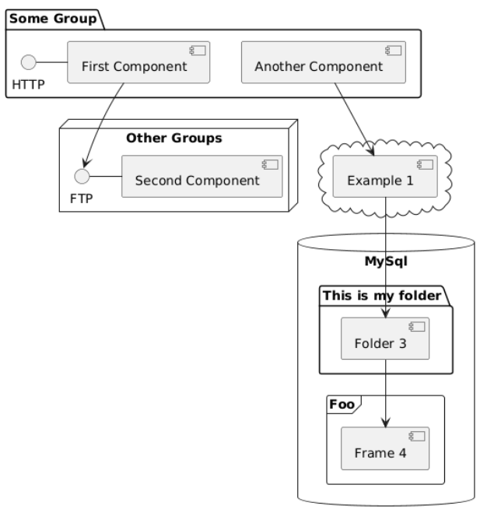

1. **Deployment Diagram**

* Purpose: Models the physical deployment of software artifacts (e.g., executables, libraries) on hardware nodes.
* Key Elements: Nodes, artifacts, and communication paths.
* Example: A web application deployed on a Web Server node and a database deployed on a Database Server node.

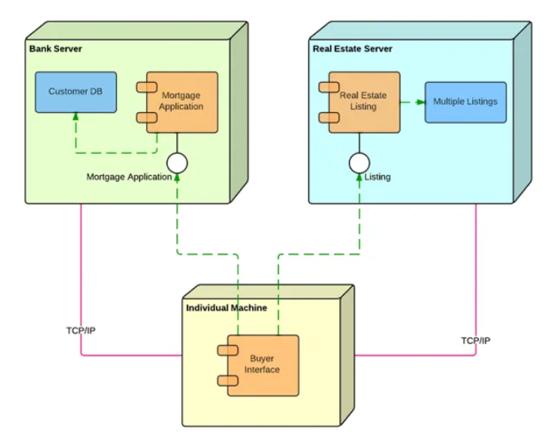

1. **Behavioral Diagrams**

Behavioral diagrams focus on the dynamic behavior of a system, representing how objects interact and how the system responds to external events.

1. **Use Case Diagram**

* Purpose: Describes the functionality of a system from the user's perspective, showing interactions between actors and use cases.
* Key Elements: Actors, use cases, and relationships.
* Example: A Customer actor interacting with use cases like Place Order and Track Order.

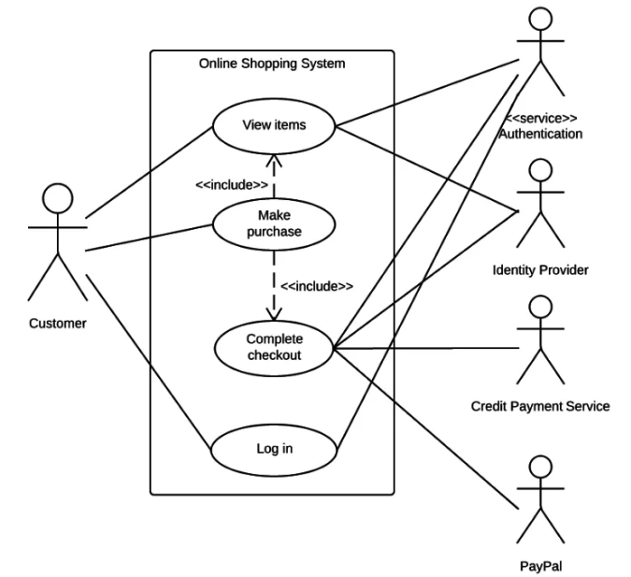

1. **Sequence Diagram**

* Purpose: Shows the interaction between objects in a time-ordered sequence, focusing on the flow of messages.
* Key Elements: Objects, lifelines, messages, and activation bars.
* Example: A sequence of messages between a Customer, Order, and Payment objects during an online purchase.

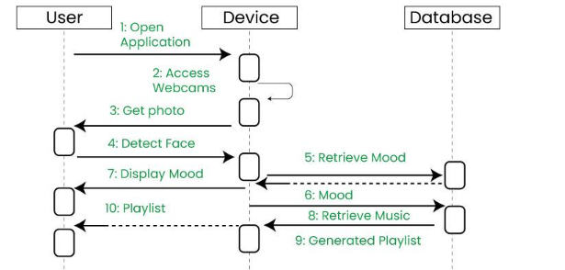

1. **Activity Diagram**

* Purpose: Models workflows, business processes, or algorithms, showing the flow of activities and decisions.
* Key Elements: Activities, decisions, forks, joins, and swimlanes.
* Example: A workflow for processing an order, including steps like Receive Order, Check Inventory, and Ship Order.

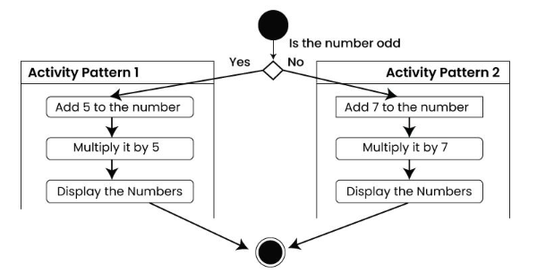

1. **State Machine Diagram**

* Purpose: Represents the states and transitions of an object in response to events.
* Key Elements: States, transitions, events, and actions.
* Example: A Order object transitioning through states like Pending, Shipped, and Delivered.
* State machine diagrams, also known as state diagrams or state-chart diagrams, are a type of behavioral diagram in UML used to represent the condition of a system or part of a system at finite instances of time
* They visually represent the dynamic behavior of a system through finite state transitions, illustrating how a system changes states in response to events.

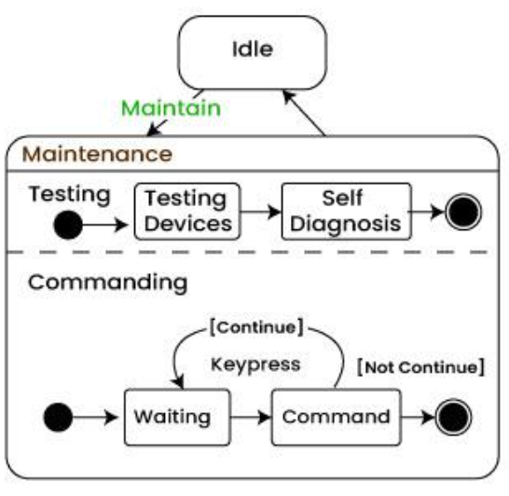

1. **Communication Diagram**

* Purpose: Shows the interaction between objects, focusing on their relationships and the messages exchanged.
* Key Elements: Objects, links, and messages.
* Example: A Customer object sending a message to an Order object to place an order.

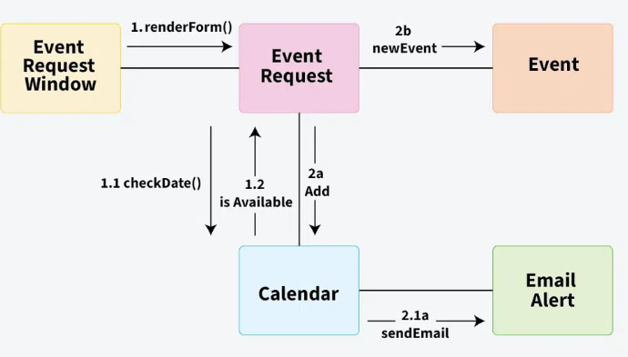

MODULE – II

CUSTOMER SUPPORT SYSTEM

**INTRODUCTION TO**

**CUSTOMER SUPPORT**

**SYSTEM**

In today’s fast-paced, technology-driven world, providing effective and timely customer support is essential for the success and growth of any organization. A Customer Support System is a structured platform designed to manage, streamline, and enhance the interaction between a company and its customers. These systems enable businesses to handle inquiries, resolve issues, and maintain strong relationships with their clients across multiple channels such as email, live chat, phone, and social media.

One of the main advantages of a customer support system is its ability to automate and organize communication. With the integration of ticketing systems, queries are tracked, categorized, and prioritized, ensuring that no issue goes unresolved or unnoticed. This organized approach helps support teams manage large volumes of requests more efficiently, ultimately reducing wait times and increasing customer satisfaction.

Moreover, customer support systems provide valuable data and analytics. These tools allow companies to track performance metrics such as response time, resolution rates, and customer feedback. By analyzing this data, businesses can identify trends, improve service quality, and make informed decisions to enhance the overall customer experience. It also enables proactive support by addressing recurring issues before they escalate.

In addition, modern customer support platforms often include self-service options like knowledge bases, FAQs, and AI-powered chatbots. These features empower customers to find solutions on their own, reducing the dependency on live agents while still offering fast and accessible support. As a result, both customers and support teams benefit from increased autonomy and efficiency.

Lastly, a well-implemented customer support system strengthens customer loyalty and brand reputation. When customers feel heard and supported, they are more likely to continue doing business with the company and recommend it to others. In competitive markets, excellent customer service can be the deciding factor that sets one brand apart from another.

* **AIM:** Analyze and design Customer Support system.

## Experiment Description:

#### Product Delivery System:

* Choose your shipping and delivery options.
* There, it shows the delivery speed (Between dates to date).
* After we have to press continue button.

## Create Order:

* Open the website (Amazon, Flipkart).
* Open the category list and search product.
* Select the item.
* Check the details of item. If it is ok add to the cart.
* If we want to buy multiple items repeat 3 & 4 steps.
* Proceed to check out the item.
* After preceding it shows the login address there we have to enter emailed &password.
* After login we have to select a delivery address if address is already
* Exist click on “deliver to this address” or else we can enter new Delivery address.
* Confirm payment details.
* **Payment Confirmation:**
* Select a payment method .There it will appears another payment method.
  + Credit Card
  + Debit Card
  + Net Banking
  + Cash on Delivery (COD)
  + We have to enter the payment information.
  + After we have to press continue button.
  + It shows valid confirmation about the product.
  + Click on confirm order.
  + Here it shows the details of our place order of the given product with price.
  + Last it will shows order successfully placed”

## Cancel order:

* + For cancelling the order, we should login with our id & password.
  + Click on select “your order”.
  + It displays “cancel request” button and press it.
  + They send cancel order confirmation to customer mail & phone number.
  + Order will be cancelled automatically within 24 hours
* **Use Cases**

#### Use case: search:

#### Primary Actor: Service Staff, customer, manager.

#### Pre-Condition: The customer to be searched should have been registered in the database ofthe customer support system.

## Main Scenario:

* + The customer or Service staff or manager logins to the system.If the login is successful.
  + Customer or Service staff or manager enters the customer name or customer id and presses search.
  + If the search is successful then that customer details will be displayedon the screen.
  + To search for a customer the Service staff or manager logins to thesystem.

## Alternative Scenario:

* 1. The login fails.
  2. The customer can re-register themselves.
  3. If the search is unsuccessful then the service staff or manager should add that members.
  4. If the book search is unsuccessful then that customer should be added.
* **Use case2: Registration:**
* **Primary Actors:** Customer.

#### Pre- Condition:

The customer should have a valid identity proof which contains his name, Date of birth, address to obtain customer id, after that the customer will be Uniquely identified by that particular customer support system.

## Main Scenario:

* + To register a customer the service staff has to first login.
  + After login the service staff searches for the existing students.
  + If the customer is already registered there is no need to register him.
  + After successful login he will be identified by unique custid.
  + A customer for customer support system is generated and provided to the customer.
  + If the customer is not already registered then his name and details is to be entered for registration.

## Alternate Scenarios:

* + The Service staff fails to login.
  + Service staff can search for his id among existing members.
  + If he is already a member and unable to login, should contact the service staff otherwise he should get re-registered.
* **Identification of Use Cases**
  + - Create new order
    - Update order
    - Produce transaction summary report
    - Lookup item availability
    - Produce order summary report
    - Lookup order status
    - Produce order fulfillment report
    - Record back order
    - Create order return
    - Record order fulfillment
    - Provide catalog information
    - Distribute promotional package
    - Create customer charge adjustment
    - Maintain customer account information
    - Produce customer adjustment report
    - Create new catalog
    - Create special promotion
    - Update catalog
    - Produce catalog activity report
* **Crud Matrix:**

SQL is consists of only 4 statements, sometimes referred to as CRUD:-

* + - * Create - INSERT - to store new data.
      * Read - SELECT - to retrieve data.
      * Update - UPDATE - to change or modify data.
      * Delete - DELETE - delete or remove data.

A CRUD matrix is a table showing the Functions in an application containing SQL statement affecting parts of a database. The CRUD Matrix is an excellent technique to identify the Tables in a database which are used in any User interaction with a Web Site. CRUD means Create, Read, Update or Delete’s and the CRUD Matrix identifies the Tables involved in any CRUD operation.

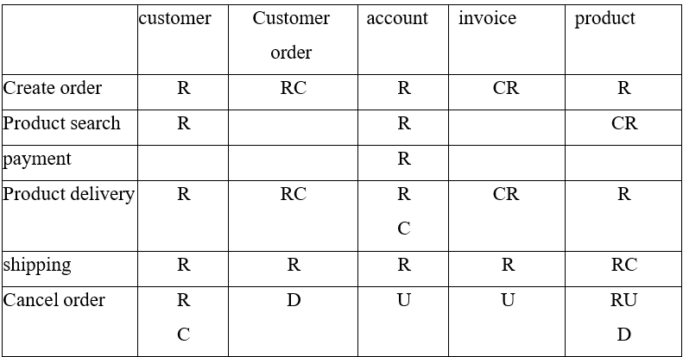

* **Events:**

Events are objects or messages used when a software components wants to notify a state change to other components. An Event model is a software architecture (a set of classes and interfaces) that determines how components can:

1. **on the event source side:**

* create and describe events
* trigger (or fire) events
* distribute events to interested components

1. **on the event listener side:**

* Subscribe to event sources.
* React to events when received.
* Remove the subscription to event sources when desired.

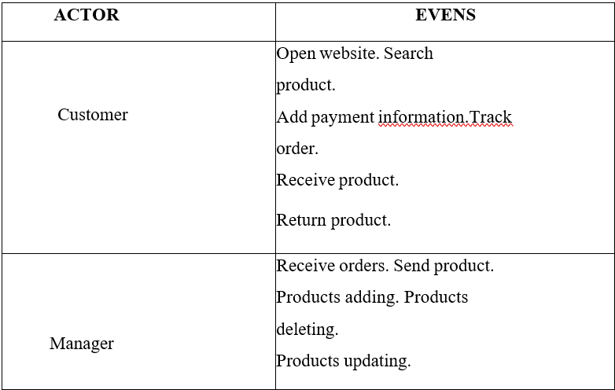

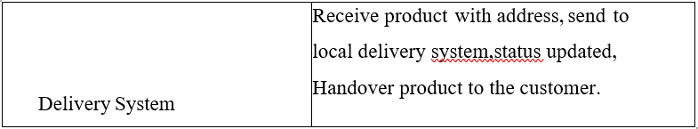

## Domain classes:

Domain classes are the abstraction of key entities, concepts or ideas these include states, use cases, and activities. Domain classes are the main elements of the domain model.

A domain model is a representation of real-world conceptual classes, not of software components. It is *not* a set of diagrams describing software classes, or software objects with responsibilities. Using UML notation, a domain model is illustrated with a set of **class diagrams** in which no operations are defined. It may show:

* Domain objects or conceptual classes
* Associations between conceptual classes
* Attribute classes Strategies
* Use a conceptual class category list.
* Identify noun phrases.

**Domain Class Diagram:**

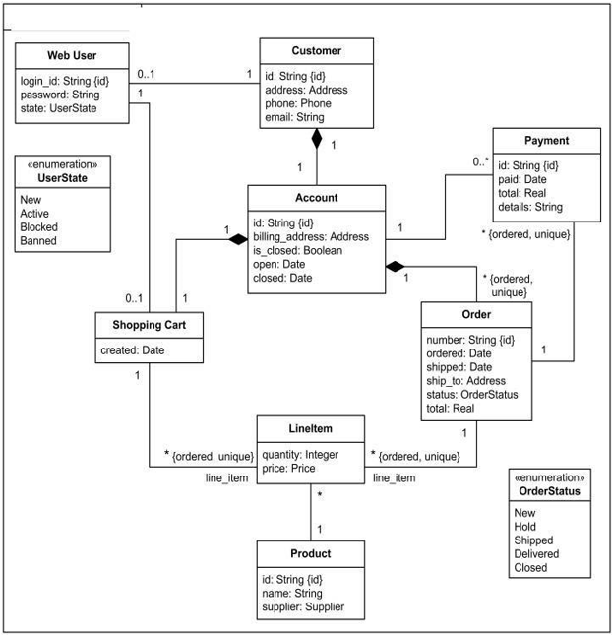

Use cases are defined to satisfy the user goals of the primary actors. Hence, the basic procedure is:

* + Choose the system boundary.
  + Identify the primary actors.
  + For each, identify their user goals.
  + Define use cases that satisfy user goals; name them according to their goal

**Use case Diagrams:**

A use case diagram shows a set of use cases and actors and their relationships.

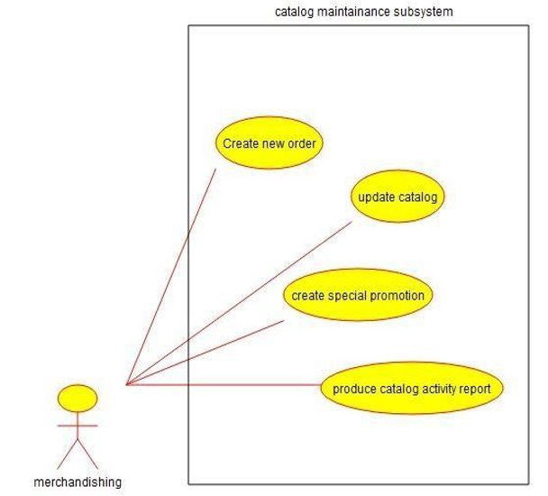

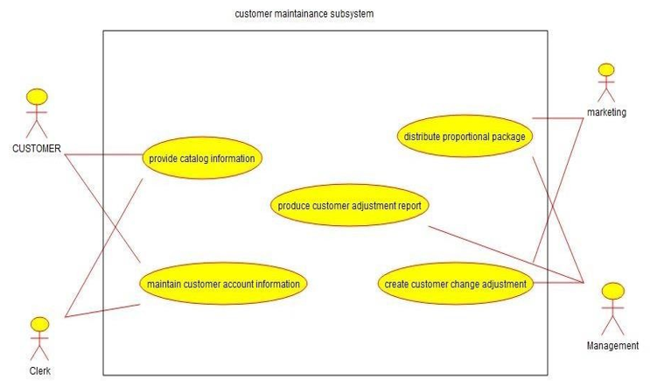

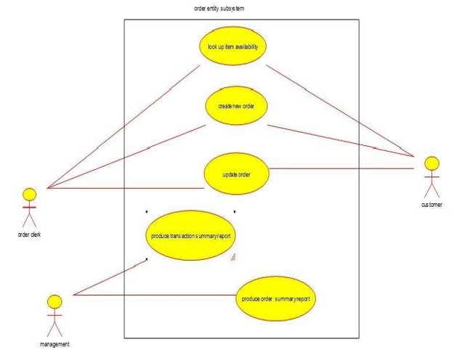

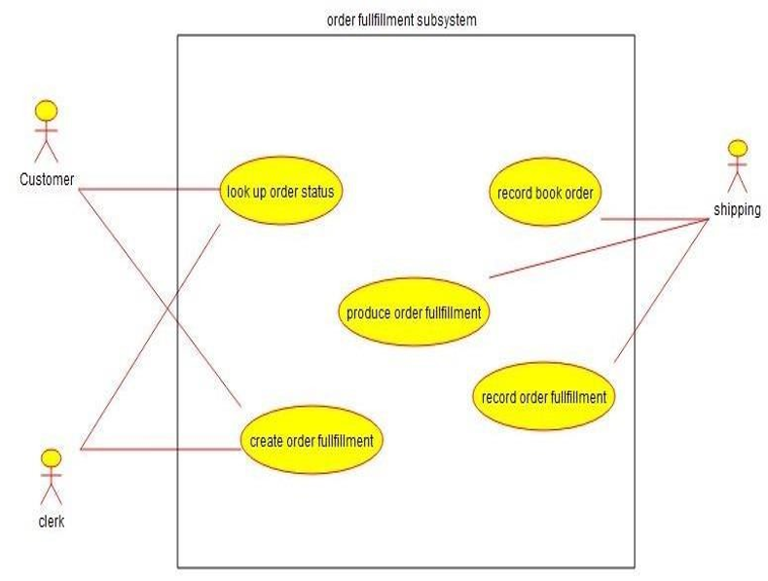

* **System sequence Diagram:**

A system sequence diagram (SSD) is a picture that shows, for a particular scenario of a use case, the events that external actors generate their order, and inter-system events. All systems are treated as a black box; the emphasis of the diagram is events that cross the system boundary from actors to systems.

A System Sequence Diagram (SSD) is a visual tool used to represent the sequence of events in a specific scenario of a use case. It illustrates how external actors—such as users or other systems—interact with the system by sending or receiving events. The system itself is treated as a black box, meaning its internal processes are not shown. Instead, the diagram emphasizes the events that cross the system boundary, focusing on inputs from actors and the system’s responses. SSDs also include interactions between the system and external components, capturing the flow of information in a clear, sequential manner.

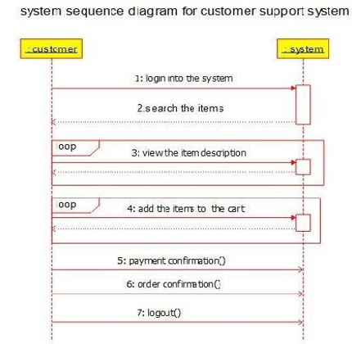

* **Sequence diagrams:**
* A sequence diagram is an interaction diagram that emphasizes the time- ordering of messages.
* This diagram is a model describing how groups of objects collaborate in some behaviour overtime.
* The diagram captures the behaviour of a single use case.
* It shows objects and the messages that are passed between these objects in the use case.

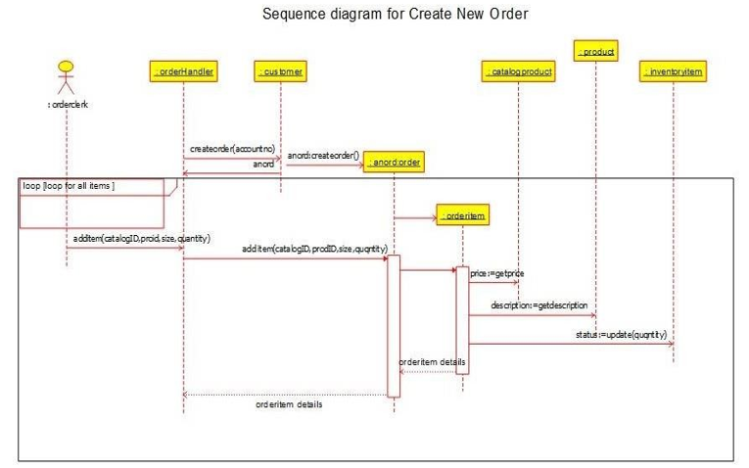

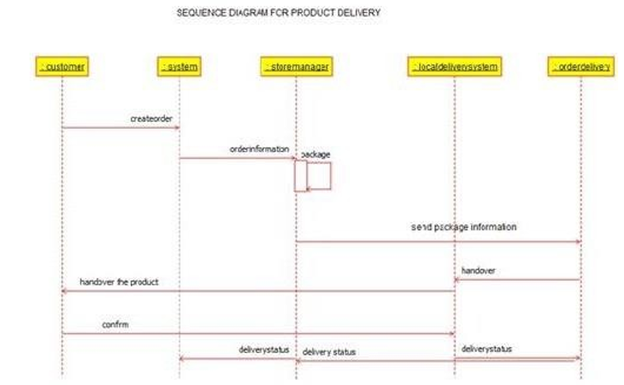

* **Collaboration Diagram:**
* Cross between a symbol diagram and a sequence diagram (interaction).
* describes a specific scenario
* Numbered arrows show the movement of messages during the course of a scenario
* When you prefer to show a spatial organization of symbols and interaction rather than concentrating on the sequence of the interaction.

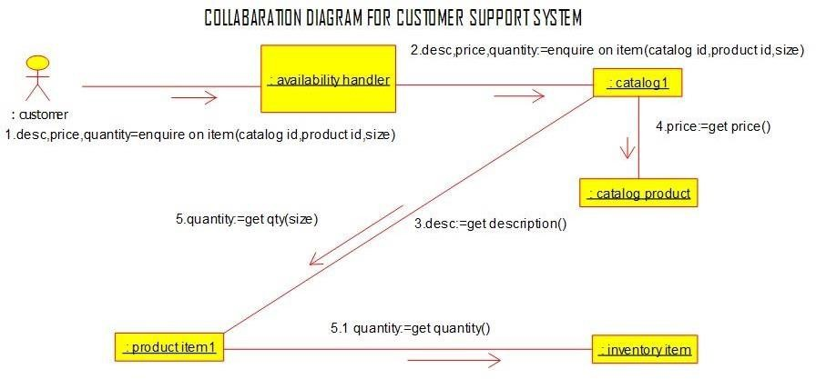

* **Class diagram:**

A class diagram shows a set of classess, interface, and collaboration and their relationship.

A **Class Diagram** is a foundational element of the Unified Modeling Language (UML) used in object-oriented software design. It provides a visual representation of the **static structure** of a system by illustrating its **classes**, their **attributes** and **methods**, and the **relationships** among them.

Each class in the diagram is depicted as a rectangle divided into three sections: the top section contains the **name of the class**, the middle section lists the **attributes** (or properties), and the bottom section outlines the **methods** (or operations) that the class can perform. These components together define the **blueprint** of an object, specifying what it knows and what it can do.

Class diagrams also show various **relationships** between classes, such as **association**, **inheritance (generalization)**, **aggregation**, **composition**, and **dependency**.

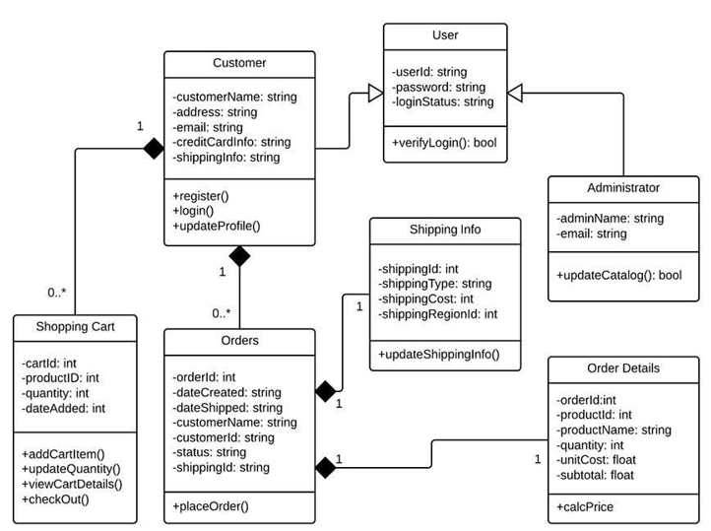

* **Activity diagrams:**

An Activity Diagram is a type of diagram used in the Unified Modeling Language (UML) to represent the flow of activities within a system or process. It focuses on the dynamic aspects of the system, showing the sequence of actions, decisions, and parallel processes that occur during a particular workflow or operation.

Activity diagrams are particularly useful for modeling business processes, system functions, and use case behaviors. They help in visualizing how different tasks are performed, who performs them (if roles are included), and how the system responds at each step.

The diagram typically starts with a start node (a filled circle), followed by a series of actions or activities, which are represented as rounded rectangles. Decision points (diamonds) are used to represent choices or conditional branches in the flow. Arrows connect all elements to show the direction of control flow. The diagram ends with a final node (a circle with a dot inside), marking the completion of the process.

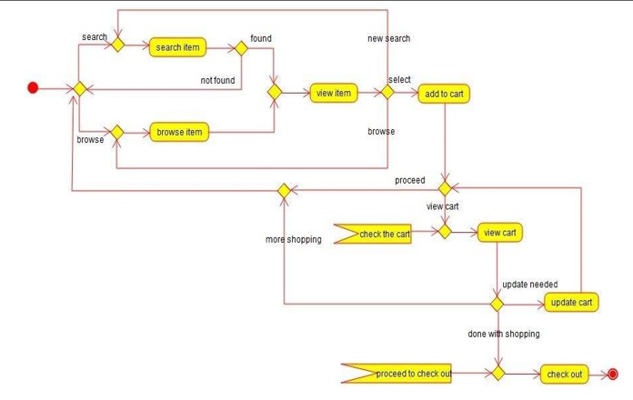

* **Activity Diagram for Store Management:**

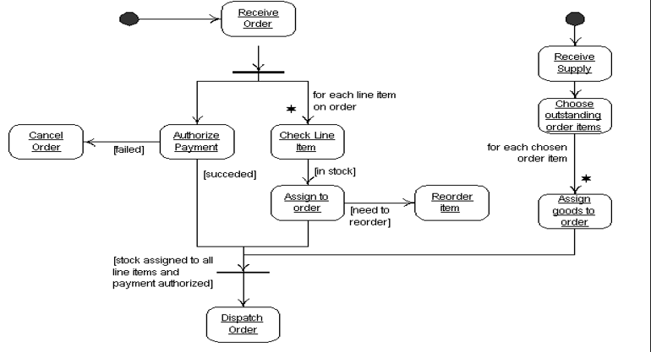

* **Use case Extensions:**

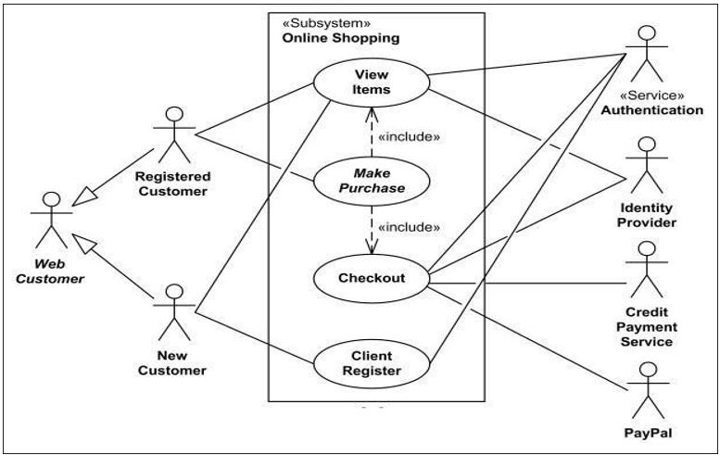

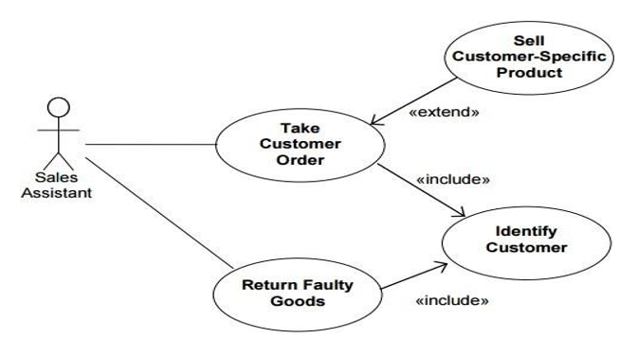

* **Component Diagram:**

A component diagram shows the dependencies among software components, including source code, binary code and executable components. Some components exist at compile time, some exist at link time, and some exist at run time; some exist at more than one time.

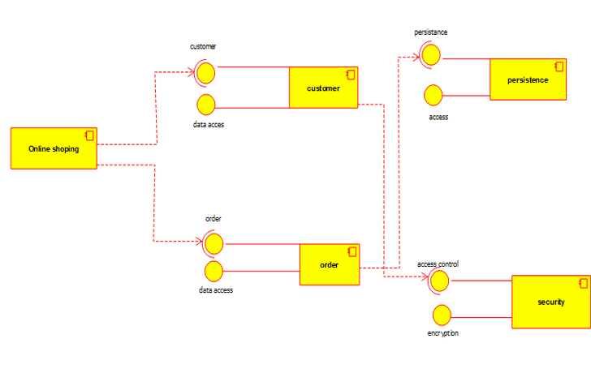

* **State diagram:**

A state chart diagram shows a state machine, consisting of states, transitions, events, and Activities.

* Provides a very detailed picture of how a specific symbols changes states.
* A state refers to the value associated with a specific attribute of an object and to anyactions or side
* Effects that occur when the attribute’s value changes
* Used when you are working on real-time process control applications or systems thatinvolve concurrent processing.
* When you want to show the behaviour of a class over several use cases.

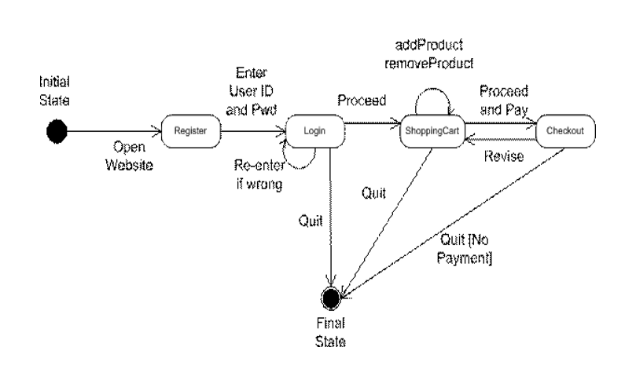

* **Layered Package Diagram:**

A package in the Unified Modeling Language is used "to group elements, and to provide a namespace for the grouped elements". A package may contain other packages, thus providing for a hierarchical organization of packages. Pretty much all UML elements can be grouped into packages.

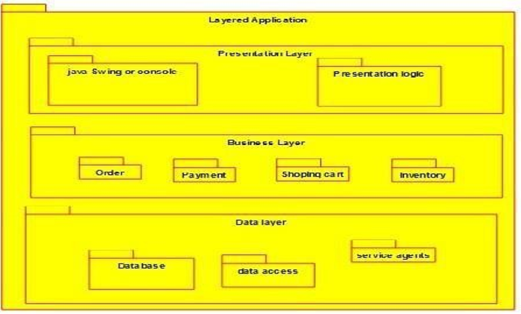

* **Deployment diagram:**

A Deployment Diagram is one of the structural diagrams in the Unified Modeling Language (UML), used to model the physical architecture of a system. It shows how software components are deployed on hardware nodes, illustrating the relationship between software and hardware in a real-world environment.

Deployment diagrams are essential in understanding how a system will be physically implemented. They represent nodes (which can be physical devices like servers, mobile phones, or network devices) and the artifacts (such as executables, databases, or components) that are deployed on these nodes. Nodes are represented as three-dimensional boxes, and artifacts are typically shown within or connected to these boxes.

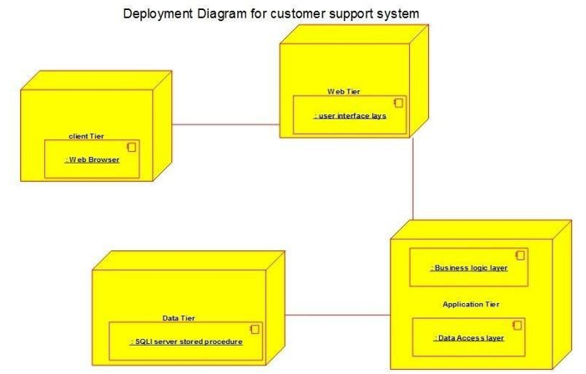

MODULE – III

NET SUPPORT WEB – SITE

**ABSTRACT**

The NetSupport website serves as a comprehensive platform designed to showcase NetSupport’s cutting-edge IT management and classroom control software. As organizations and educational institutions increasingly rely on digital solutions for seamless IT administration and remote learning support, the role of an efficient and scalable website becomes essential. This study delves into the meticulous application of Object-Oriented Software Engineering (OOSE) in the development and structural design of the NetSupport website. By leveraging fundamental object-oriented programming principles such as encapsulation, inheritance, polymorphism, and modularity, the system achieves an optimized level of scalability, maintainability, security, and overall system performance.

The research begins by identifying and defining key objects and classes within the website’s system architecture. This includes core components such as Users, Products, Orders, and Support Tickets, with their interactions being visually represented through Unified Modelling Language (UML) diagrams. These diagrams effectively highlight the hierarchical relationships between different objects and showcase the modular design approach, ensuring streamlined functionality and effortless system expansion. Furthermore, the study explores the implementation process, detailing the utilization of modern programming technologies such as Java, Python (Django), JavaScript (React, Vue.js), PostgreSQL, MySQL, OAuth-based security frameworks, and cloud-based deployment. These technologies work cohesively to enhance website reliability, system responsiveness, and user accessibility

**INTRODUCTION TO**

**NET SUPPORT WEBSITE**

In today’s digital era, businesses and organizations rely heavily on technology to operate efficiently. A Net Support Website serves as a crucial online platform for providing technical support, troubleshooting, and customer assistance. The development of such a system involves complex software engineering principles, and Object-Oriented Software Engineering (OOSE) plays a vital role in ensuring the efficiency, maintainability, and scalability of the website. This essay explores the importance of Net Support Websites, their object-oriented structure, and the benefits of applying OOSE principles in their development.

* **Understanding Net Support Websites**

A Net Support Website is an online platform that facilitates customer service through various support mechanisms, including ticket management systems, live chat, knowledge bases, and remote troubleshooting tools. These websites help users resolve technical issues efficiently by connecting them with support agents or providing self-help resources. Common features of a Net Support Website include:

* User Registration and Authentication – Ensuring secure access for customers and support agents.
* Ticket Management System – Allowing users to submit, track, and resolve queries.
* Live Chat and AI Chatbots – Enabling real-time communication between users and support representatives.
* Knowledge Base and FAQs – Providing self-help articles and tutorials.
* Remote Assistance – Allowing support agents to access users’ systems remotely for troubleshooting.

To build a scalable and modular Net Support Website, Object-Oriented Software Engineering principles must be applied to ensure an efficient and well-structured system.

* **Object-Oriented Approach in Net Support Websites**

Object-Oriented Software Engineering (OOSE) is a methodology that utilizes object-oriented principles in software development. It focuses on designing software based on real-world entities, making the system more modular, reusable, and scalable.

* 1. **Object-Oriented Structure of a Net Support Website**

A Net Support Website can be modeled using several core classes and objects:

* **User Class:** Represents all users interacting with the system, including customers and support agents.
* **Attributes:** userID, name, email, role
* **Methods:** login(), logout(), updateProfile()
* Customer Class (Inherits from User)**:** Represents customers seeking support.
* **Additional Attributes:** customerID, issueHistory
* **Methods:** createTicket(), searchKnowledgeBase()
* SupportAgent Class (Inherits from User)**:** Represents technical support personnel
* **Additional Attributes:** agentID, expertise
* **Methods:** resolveTicket(), chatWithCustomer()
* Ticket Class: Manages support tickets submitted by customers.
* **Attributes:** ticketID, status, priority, description, assignedAgent
* **Methods:** updateStatus(), assignAgent(), closeTicket()
* KnowledgeBase Class**:** Stores FAQs and articles for self-help.
* **Attributes:** articleID, title, content, category
* **Methods:** searchArticle(), addArticle(), updateArticle()
* **Advantages of Using OOSE in Net Support Websites**

Applying Object-Oriented Software Engineering principles in the development of Net Support Websites offers several advantages:

* **Modularity** – Components of the system are developed as independent objects, making maintenance and updates easier.
* **Reusability** – Code reuse is maximized through inheritance, reducing development time and effort.
* **Scalability** – The system can be extended by adding new features without major structural changes.
* **Improved Maintainability** – Encapsulation ensures that data remains secure and changes in one module do not affect others unnecessarily.
* **Better User Experience** – A well-structured system enhances the efficiency of customer support, leading to improved user satisfaction.

**PROBLEM STATEMENT**

In today’s digital landscape, organizations rely heavily on IT networks to maintain seamless operations. However, network failures, slowdowns, and security breaches frequently disrupt business processes, leading to inefficiencies and financial losses. Many organizations struggle with managing and resolving network-related issues efficiently due to the lack of a centralized, automated, and user-friendly support system. Traditional IT support methods are often manual, reactive, and time-consuming, making it difficult to track, prioritize, and resolve issues effectively. To address these challenges, a Net Support Website, developed using Object-Oriented Software Engineering (OOSE) principles, can provide a scalable and structured approach to network issue management.

* **The Purpose of a Net Support Website**

The primary purpose of a Net Support Website is to provide a comprehensive and automated solution for managing IT network issues efficiently. By offering a centralized platform, organizations can streamline the process of issue tracking, troubleshooting, and resolution. The website is designed to enhance IT support by providing users with a structured and intuitive interface to report problems, access self-help resources, and communicate with IT teams in real time.

Furthermore, the website aims to reduce downtime, improve response times, and ensure proactive maintenance of network infrastructure. By leveraging Object-Oriented Software Engineering principles, the system can offer modular, scalable, and reusable components, making it adaptable to future technological advancements. Ultimately, the Net Support Website serves as a crucial tool for organizations to maintain a stable and secure network environment while optimizing resource allocation and IT workforce efficiency.

* **The Challenges in IT Network Support**

The primary issue faced by organizations is the inefficiency of manual IT support systems. Conventional methods, such as email-based ticketing, phone calls, and verbal communication, often lead to miscommunication, delayed responses, and a lack of transparency. Additionally, IT teams frequently encounter difficulties in prioritizing support requests due to the absence of automated categorization and escalation mechanisms. As a result, critical network issues may remain unresolved for extended periods, causing disruptions in business continuity.

Another major challenge is the lack of a structured and well-maintained knowledge base. Many IT support teams operate without a centralized repository of previously resolved issues, leading to redundant troubleshooting efforts and increased resolution times. Furthermore, without proper logging and tracking mechanisms, organizations cannot analyze recurring network problems or predict potential failures.

* **The Need for a Net Support Website**

To overcome these challenges, a Net Support Website can serve as an integrated solution for network issue tracking and resolution. By leveraging Object-Oriented Software Engineering principles, this system can be designed to be modular, scalable, and maintainable. Object-oriented design allows for the creation of reusable components, making it easier to enhance and extend the system over time. Key features of this Net Support Website would include:

* **Automated Ticketing System** – Users can report network issues through an intuitive interface, generating support tickets that are automatically categorized and prioritized based on severity.
* **Real-Time Troubleshooting** – The system can provide instant diagnostic tools and AI-based recommendations to help users resolve minor issues without IT intervention.
* **Knowledge Base and Documentation** – A centralized repository of past network issues and solutions can help IT teams and users troubleshoot recurring problems efficiently.
* **Seamless Communication** – Built-in chat, email, and notification systems allow users and IT support staff to interact smoothly, ensuring quick updates and resolutions.
* **Performance Analytics and Predictive Maintenance** – The system can analyze network logs to detect patterns and predict potential failures, enabling proactive maintenance.
* **Role-Based Access Control** – Ensuring data security by restricting access to authorized personnel only.
* **Object-Oriented Software Engineering Approach**

Implementing a Net Support Website using Object-Oriented Software Engineering principles ensures the system remains flexible and adaptable to future needs. OOSE promotes:

* **Encapsulation** – Protecting sensitive data and ensuring that internal workings of the system are hidden from users who do not need direct access.
* **Inheritance** – Allowing for the reuse of existing components to reduce redundancy in code.
* **Polymorphism** – Enabling different types of users (e.g., IT staff, employees, and administrators) to interact with the system through a common interface while receiving personalized functionalities.
* **Modularity** – Breaking down the system into smaller, manageable components such as issue tracking, user authentication, and analytics, making it easier to maintain and upgrade.

**NET SUPPORT WEBSITE**

**MODULES**

Object-Oriented Analysis (OOA) plays a crucial role in designing a Net Support Website by focusing on identifying the key objects, their attributes, and interactions within the system. This approach ensures a modular, scalable, and maintainable system structure.

* **Identifying Key Objects**
* **The primary objects in the system include:**
* User (IT staff, employees, administrators)
* **Attributes**: User ID, name, role, contact information
* **Methods**: Create ticket, update ticket, close ticket, search knowledge base
* Support Ticket (issue description, priority, status, resolution history)
* **Attributes:** Ticket ID, issue description, creation date, priority level, current status, resolution history
* **Methods**: Assign ticket, update status, resolve ticket, link knowledge base article
* Knowledge Base (articles, FAQs, troubleshooting guides)
* **Attributes**: Article ID, title, content, related issues
* **Methods**: Search article, update content, link to support ticket
* Communication Module (chat system, notifications, email alerts)
* **Attributes**: Message ID, sender, recipient, timestamp, message content
* **Methods**: Send message, receive message, trigger email alert
* Analytics Module (logs, reports, predictive maintenance data)
* **Attributes**: Report ID, generated reports, system logs, predictive insights
* **Methods**: Generate reports, update logs, analyze trends
* **Defining Object Relationships**

The relationships between objects define how they communicate, share data, and influence each other within a system. These relationships establish the structure and behavior of the system, determining how objects collaborate to achieve specific functionalities.

**Examples include:**

* A User can create multiple Support Tickets.
* A Support Ticket is assigned to an IT Staff member for resolution.
* A Knowledge Base entry can be linked to multiple Support Tickets as a reference.
* The Analytics Module continuously updates based on resolved tickets and system logs.
* The Communication Module facilitates interaction between users and IT staff via chat and email alerts.
* **Defining Key Classes**

Each identified object is converted into a class with attributes and methods:

* User Class (Superclass)
* **Attributes**: userID, name, email, role, password, contactNumber
* **Methods**: login(), logout(), updateProfile(), viewTickets()
* Customer (Subclass of User)
* **Attributes**: accountType, organization
* **Methods**: createTicket(), trackTicketStatus(), searchKnowledgeBase(), requestLiveChat()
* SupportAgent (Subclass of User)
* **Attributes**: agentID, expertiseArea
* **Methods**: assignTicket(), respondToTicket(), updateKnowledgeBase(), endChatSession()
* Admin (Subclass of User)
* **Attributes**: adminID, privileges
* **Methods**: manageUsers(), generateReports(), monitorTickets()
* SupportTicket Class
* **Attributes**: ticketID, customerID, subject, description, status, priority, assignedAgent, createdAt
* **Methods**: updateStatus(), addComment(), closeTicket()
* KnowledgeBase Class
* **Attributes**: articleID, title, content, category, lastUpdated
* **Methods**: searchArticles(), addArticle(), updateArticle(), deleteArticle()
* LiveChat Class
* Attributes: chatID, customerID, agentID, chatHistory, status
* Methods: startChat(), sendMessage(), endChat()
* Feedback Class
* **Attributes**: feedbackID, ticketID, rating, comments, submittedBy
* **Methods**: submitFeedback(), viewFeedback(), analyzeFeedback()

* **Establishing Relationships**
* A Customer can create multiple Support Tickets.
* A Support Agent is assigned to a Support Ticket.
* A Knowledge Base contains multiple articles, accessible to all users.
* A LiveChat session is linked to both Customer and SupportAgent.
* A Feedback entry is linked to a Support Ticket after resolution.
* **UML Representation**
* **Class Diagram:** Represents relationships between User, SupportTicket, KnowledgeBase, etc.
* **Sequence Diagrams:** Show how users interact with the support system.
* **Use Case Diagrams**: Define key user interactions (e.g., "Submit Ticket," "Chat with Agent").
* **Activity Diagrams**: **Activity Diagrams** are used to model the workflow of a system, representing the sequence of activities and actions that occur in a particular process.
* **State Chart Diagrams**: **State Chart Diagrams** are used to model the dynamic behaviour of an object in response to events, showing how an object transitions between various states.
* **Component Diagrams**: **Component Diagrams** are used to model the physical components of a system and their interactions. They provide a high-level view of how software components interact with each other
* **Deployment Diagrams**: Deployment Diagrams model the physical architecture of a system by showing how software components are deployed across hardware nodes.
* **Behavioral Analysis**

Behavioral analysis helps define the actions and functionalities of objects by examining how they interact, respond to inputs, and change states within a system. This is achieved through:

* **Use Case Diagrams** – Illustrating user interactions with the system.
* **Sequence Diagrams –** Mapping out the step-by-step process of issue resolution.
* **Class Diagrams** – Defining object attributes and methods for modular development

.

* **Ensuring Scalability and Maintainability**

By adopting OOA principles, the Net Support Website remains adaptable to future updates. Additional objects and functionalities can be integrated without disrupting existing components. Examples of future enhancements include:

* AI-driven ticket triaging to categorize and prioritize tickets automatically.
* Enhanced security protocols for safeguarding user data.
* Machine learning integration for predictive issue resolution.
* Automated responses to handle common support queries efficiently.
* **UML DIAGRAMS**

A Net Support Website is an online platform that provides customer support services through features such as live chat, ticketing systems, knowledge bases, and user management. Unified Modeling Language (UML) is a standardized notation used in software engineering to visualize, specify, and document system architecture.

For a Net Support Website, various UML diagrams can be utilized to represent different aspects of the system, including structure, behavior, and interactions. Below are the key UML diagrams that can be designed for this system.

1. **Class diagram for Net Support Web – Site**

A Net Support Website is a platform designed to provide customer support services through various channels, including live chat, ticketing systems, and knowledge bases. In object-oriented software engineering, a Class Diagram is a crucial part of Unified Modeling Language (UML) that illustrates the static structure of a system by defining its classes, attributes, methods, and relationships. This essay explores the design and significance of a class diagram for a Net Support Website.

* **Understanding Class Diagrams**

A class diagram represents the fundamental building blocks of a system by detailing its structure and relationships. It consists of:

Classes: Represent entities within the system.

Attributes: Define the properties of classes.

Methods: Specify the behaviors of classes.

Relationships: Indicate associations, generalizations, dependencies, and aggregations between classes

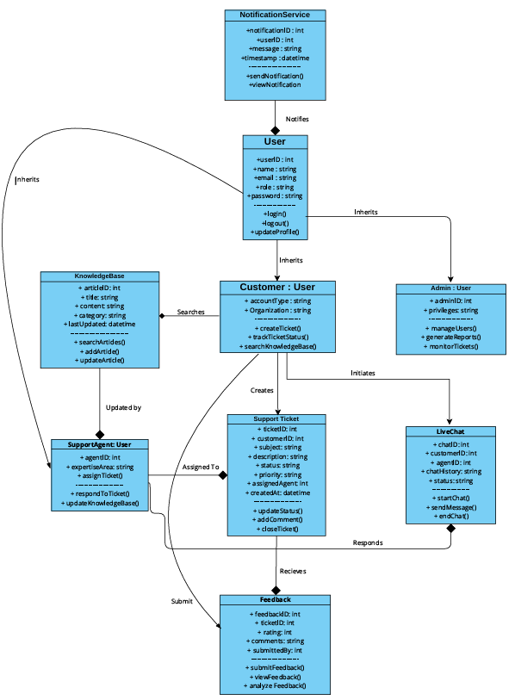

* **Sequence Diagram of Net Support Web – Site:**

A sequence diagram is a type of Unified Modeling Language (UML) diagram that illustrates how objects interact in a particular scenario of a system. It emphasizes the sequence of messages exchanged between objects over time. In the context of a Net Support Website, a sequence diagram is essential for visualizing the interactions between customers, support agents, the net support system, and the database.

* **Understanding Sequence Diagrams**

A sequence diagram consists of the following key elements:

* Actors: Represent users or external systems interacting with the system (e.g., Customers, Support Agents, Admins).
* Objects: Represent components of the system involved in the interaction (e.g., Net Support System, Database).
* Lifelines: Indicate the lifespan of an object during the interaction.
* Messages: Show the interactions between objects, such as method calls and responses.
* Activation Bars: Represent the period an object is active during an interaction.

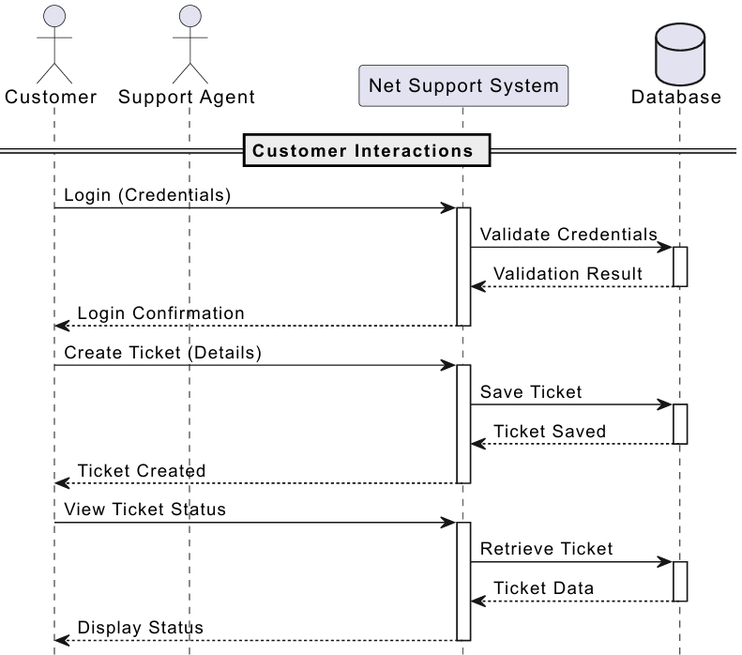

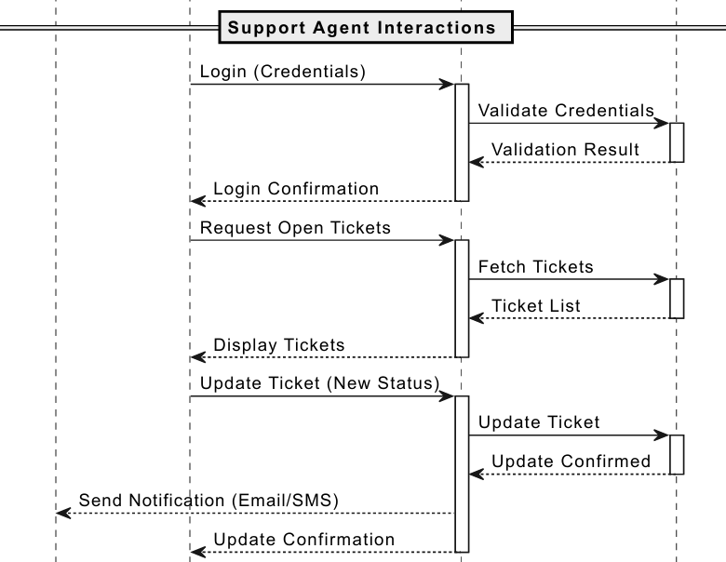

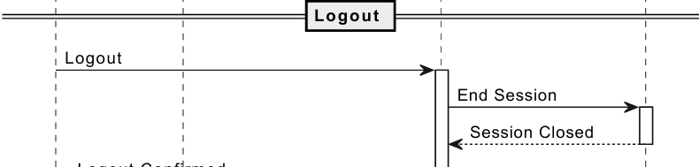

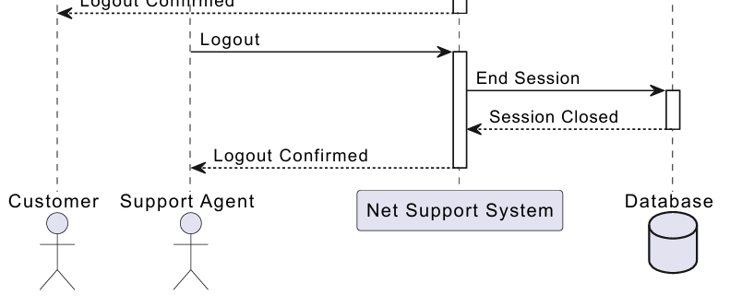

* **USE CASE DIAGRAM FOR NET SUPPORT**

**WEB – SITE**

A Net Support Website is an essential platform for providing technical support, troubleshooting, and customer assistance through various communication channels. In object-oriented software engineering, a Use Case Diagram is a fundamental part of the Unified Modeling Language (UML) that visually represents how users (actors) interact with the system’s functionalities. This essay explores the design and significance of a use case diagram for a Net Support Website.

* **Understanding Use Case Diagrams**

A use case diagram provides a high-level representation of the system’s functionalities and the different user roles that interact with them. It consists of:

* Actors: Represent external users or other systems that interact with the website.
* Use Cases: Define the different functionalities or operations of the system.
* Relationships: Show associations between actors and use cases.

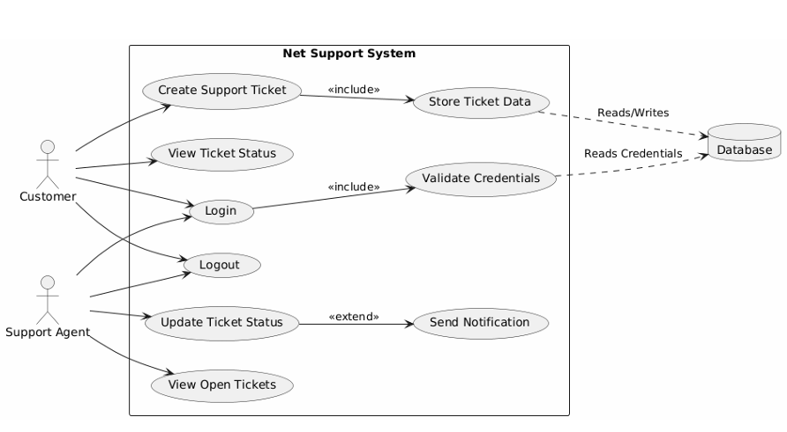

* **ACTIVITY DIAGRAM FOR NET SUPPORT**

**WEB – SITE**

A Net Support Website provides a platform for users to receive technical support, submit tickets, and communicate with support agents. In object-oriented software engineering, an Activity Diagram is a crucial part of the Unified Modeling Language (UML) that visually represents the flow of processes and activities within the system. Activity diagrams help in understanding the dynamic aspects of a system by depicting the sequence of operations and decision-making processes.

They provide a high-level overview of how users interact with different functionalities, ensuring clarity in system design and implementation. By illustrating workflows, activity diagrams assist developers, analysts, and stakeholders in optimizing the user experience, identifying bottlenecks, and improving system efficiency. This essay explores the design and significance of an activity diagram for a Net Support Website, highlighting its key activities, relationships, and overall importance in system development.

* **Understanding Activity Diagrams**

An activity diagram is a graphical representation of workflows within a system. It captures dynamic aspects, illustrating how different processes interact to achieve specific goals. The main components of an activity diagram include:

* Activities: Represent various tasks or operations in the system.
* Transitions: Indicate the flow between activities.
* Decisions: Represent conditional flows based on user input or system states.
* Swimlanes: Divide activities among different actors for clarity.
* Start and End Nodes: Indicate the beginning and conclusion of a process.

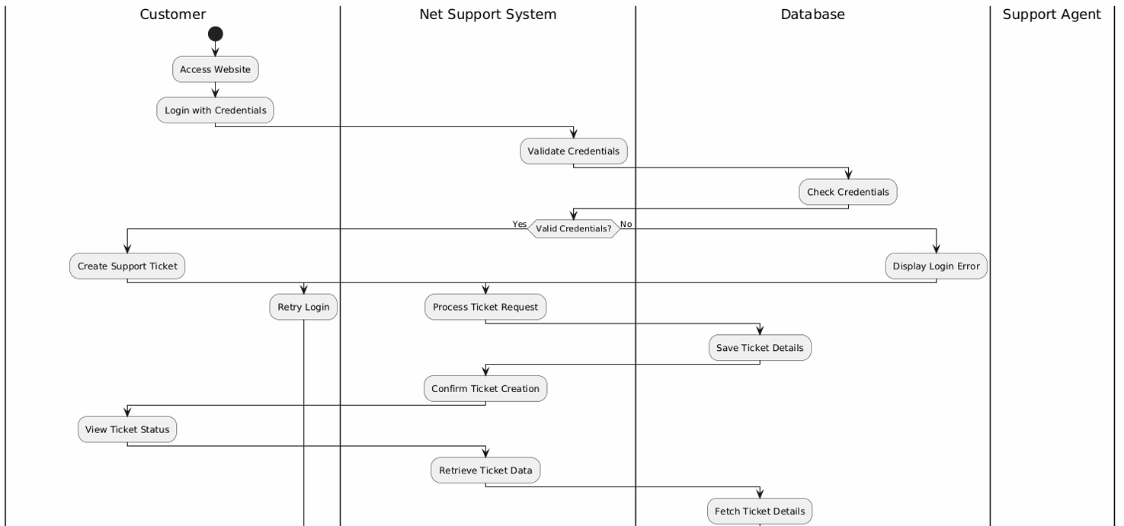

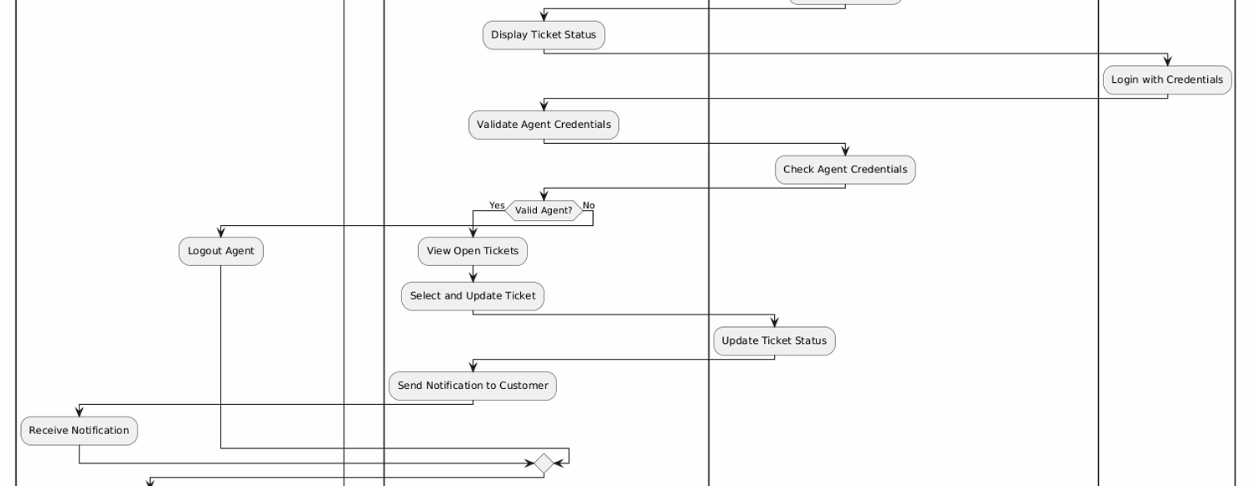

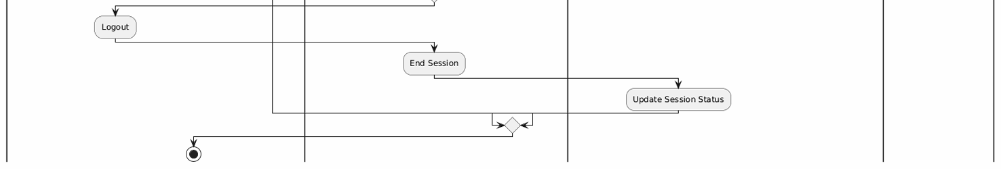

* **STATE CHART DIAGRAM FOR NET SUPPORT**

**WEB – SITE**

A State Chart Diagram is a behavioural diagram in UML (Unified Modelling Language) that represents the states and transitions of an entity in a system. For a Net SupportWebsite, a state chart diagram helps visualize how the system behaves based on user interactions, system processes, and error handling mechanisms.

This type of diagram is particularly useful in mapping out the various states a user or system component can experience, including transitions triggered by specific actions or events. By defining these states clearly, developers and system designers can anticipate potential issues, streamline workflows, and ensure a seamless user experience. Additionally, the diagram allows for better debugging, as it provides a structured representation of possible system failures and recovery processes.

* **Importance of State Chart Diagram**

The primary objective of a state chart diagram for a **Net Support Website** is to model the various states a user or system component goes through during interaction. It helps in:

* Understanding user navigation flow
* Identifying system responses to user actions
* Aiding in software development and debugging
* Enhancing customer support services by identifying failure points

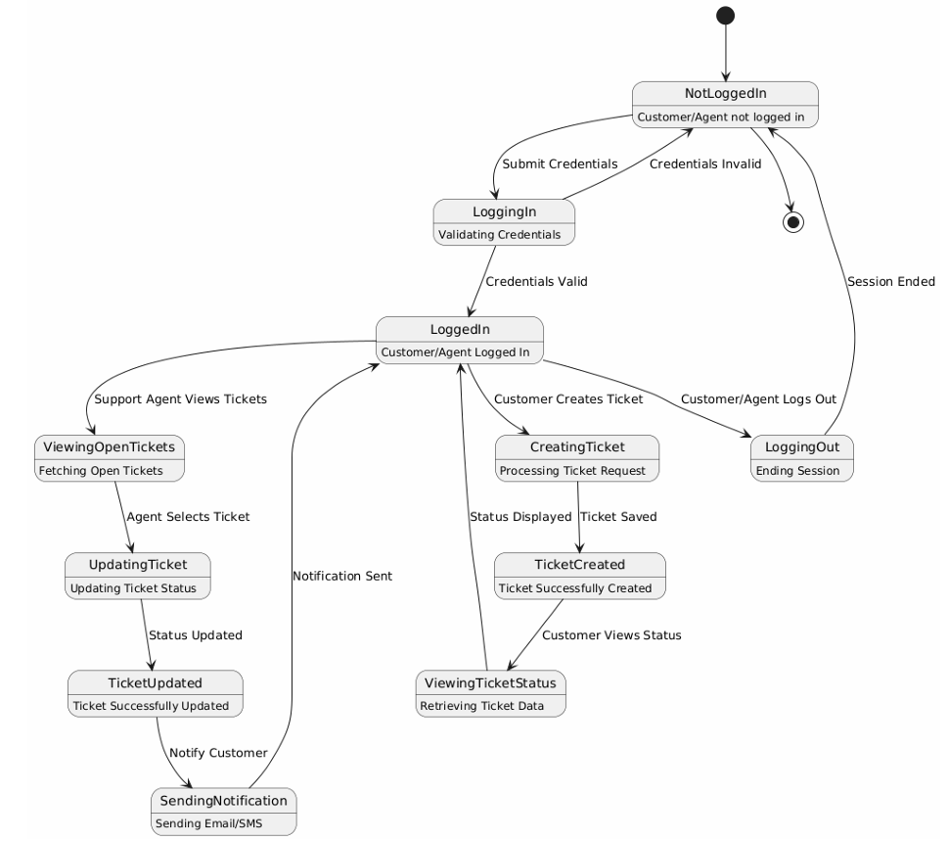

* **COMPONENT DIAGRAM OF A NET SUPPORT**

**WEB - SITE**

A Component Diagram is a type of UML (Unified Modeling Language) diagram that represents the physical components of a system and their interrelationships. It helps in visualizing the structure of a system, depicting how different software components interact with each other. For a Net Support Website, a component diagram illustrates how various elements, such as the user interface, database, web server, and support modules, function together to provide seamless technical support. By mapping these components, developers and system architects can design a robust and efficient architecture that ensures smooth operation and easy troubleshooting.

The component diagram also highlights dependencies between different modules, helping teams understand how changes in one part of the system might affect others. Additionally, it provides a high-level view of the system’s modularity, making it easier to scale and integrate new features over time. With clear visualization of interactions, the component diagram aids in optimizing performance, reducing redundancy, and ensuring that all system elements work harmoniously to deliver effective support services to users.

* **Importance of Component Diagram**

The Component Diagram is essential in the design and development of a Net Support Website as it:

* Helps developers understand system architecture and dependencies.
* Facilitates scalability by clearly defining modular components.
* Assists in troubleshooting and debugging by mapping component interactions.
* Enhances collaboration among developers, designers, and stakeholders.

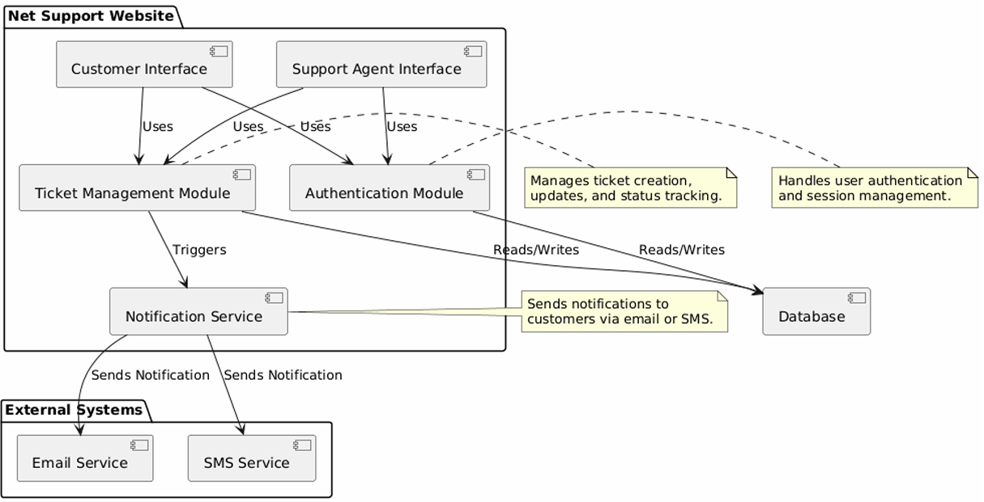

* **DEPLOYMENT DIAGRAM OF NET SUPPORT**

**WEB – SITE**

In the world of web applications, deployment diagrams play a crucial role in understanding how different components interact in a live environment. These diagrams help visualize the physical structure of a system, detailing how hardware and software components work together to deliver seamless functionality. They provide an essential blueprint for developers, system architects, and network administrators to optimize performance, troubleshoot issues, and enhance security. By mapping out the interactions between servers, databases, client devices, and other infrastructure elements, deployment diagrams ensure a systematic approach to deploying and managing web applications.

A deployment diagram is a type of UML (Unified Modeling Language) diagram that showcases the physical architecture of a system, including hardware, software, and their relationships. It outlines various nodes, artifacts, and their connections, helping stakeholders understand how information flows within the system. This essay explores the deployment diagram of a Net Support website, highlighting its components, structure, and significance.

* **Understanding Deployment Diagrams**

A deployment diagram represents the physical arrangement of software components across hardware nodes. It provides a clear picture of how various elements, such as web servers, databases, and client devices, interact in a networked environment. The key components of a deployment diagram include:

* Nodes: Represent hardware devices such as servers and client machines.
* Artifacts: Represent the software deployed on the nodes.
* Connections: Define the communication between nodes

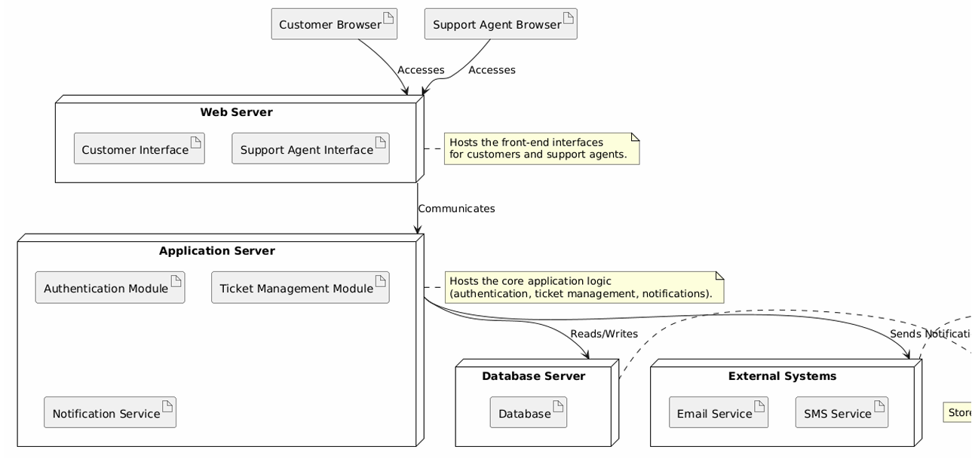

**CONCLUSION:**

In conclusion, the Net Support website serves as a comprehensive and user-friendly platform for delivering technical assistance and remote support services. It provides a reliable solution for both individuals and organizations looking to resolve technical issues efficiently and securely. With features such as real-time chat, remote desktop access, troubleshooting tools, and knowledgeable support staff, the website enhances customer satisfaction and minimizes system downtime.

The site’s clear layout, responsive design, and accessible support options make it an essential tool for users seeking immediate and professional help. Overall, Net Support proves to be a valuable digital resource, offering effective technical support and contributing to smoother, uninterrupted use of technology in various settings.

In conclusion, the Net Support website serves as a comprehensive and user-friendly platform for delivering technical assistance and remote support services. It provides a reliable solution for both individuals and organizations looking to resolve technical issues efficiently and securely. With features such as real-time chat, remote desktop access, troubleshooting tools, and knowledgeable support staff, the website enhances customer satisfaction and minimizes system downtime.